**Perception Module**

**Checkpoint 1:** Knew about Python beforehand. Solved the exercises in w3schools.com as revision.

**Checkpoint 2:**

* What is an image?

An image is a 2d(sometimes 3d) array of pixels and their corresponding intensities. We can imagine an image to be a matrix of pixel values from 0 to 255, representing colours from black to white correspondingly.

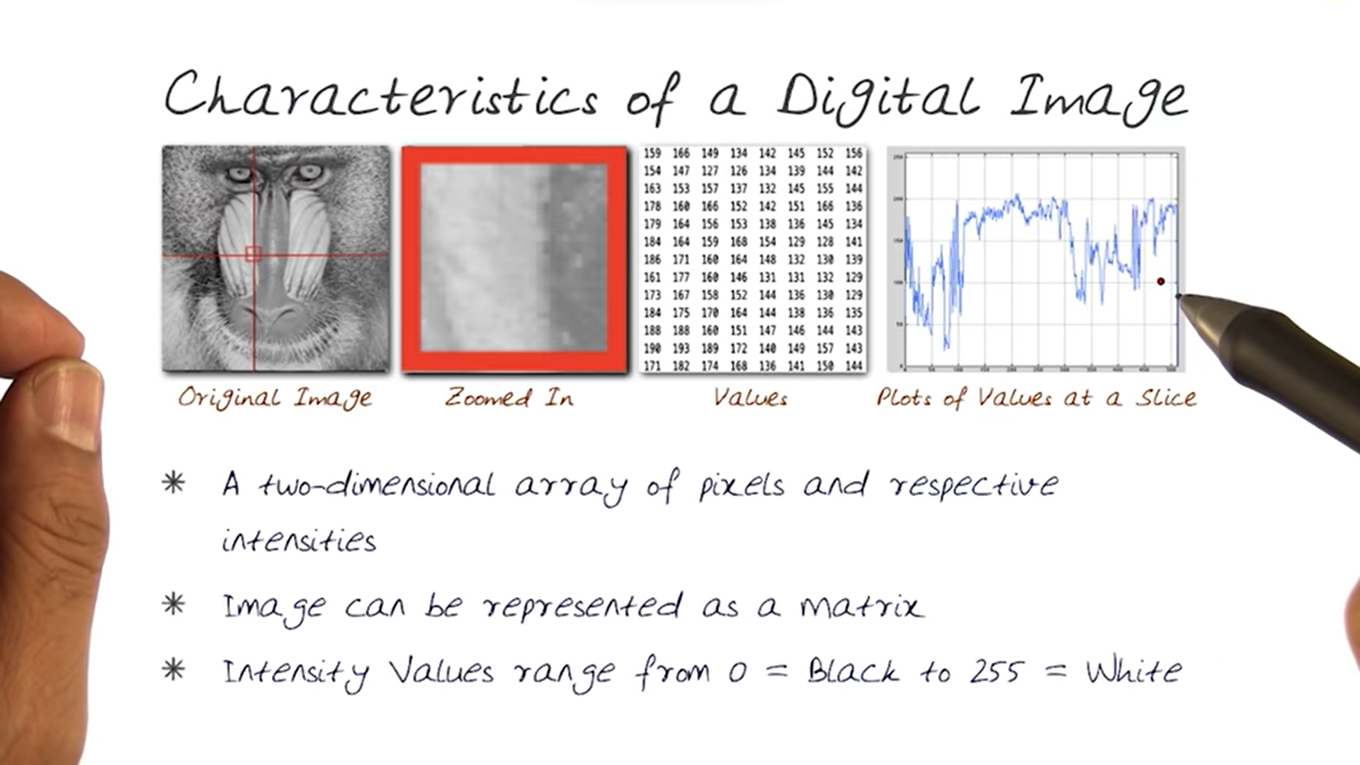

As seen in the above SS(from one of the videos), the black-and-white image of the monkey’s face is seen by the computer as a matrix(3rd image), and we need to make the computer extract meaningful information from these values.

In real life, however, images are not black and white, but rather coloured. So, the computer perceives it as a 3D matrix in which one of the axis represents the colour channels i.e. R/G/B. Each pixel will have a particular value corresponding to each of the channels and when we blend the images, we get our original image.

Note:- for a digital image, we need to quantize our image, i.e. we need to round off each pixel value to the nearest integer.

* Now that we understand what an image is, what to do next? We need to reduce the noise in the image. This helps in edge detection as noises or abrupt changes in the pixel intensities tend to interfere and obscure the edges making the edge detection difficult. Also, sometimes the algorithm may recognise false edges which need to be prevented. Keeping this in mind, there are several techniques used for smoothening of images. One of the processes used is smoothening using averages.

In this method, every pixel is assigned a value equal to the average of the pixel values of its neighbours. For eg. if we consider a 3x3 matrix, then the middle pixel will be assigned the average of all 9 pixels in around it. Essentially, this is like multiplying every 3x3 box in the image by another 3x3 matrix having all elements equal to 1/9. When we iterate this all over the image, we get another matrix which corresponds to another image. Now, each pixel in the new matrix is basically a function of all the pixels around it and thus the abruptness in the values will decrease significantly. Thus, the new image will be free from noises and can be used for further processing.

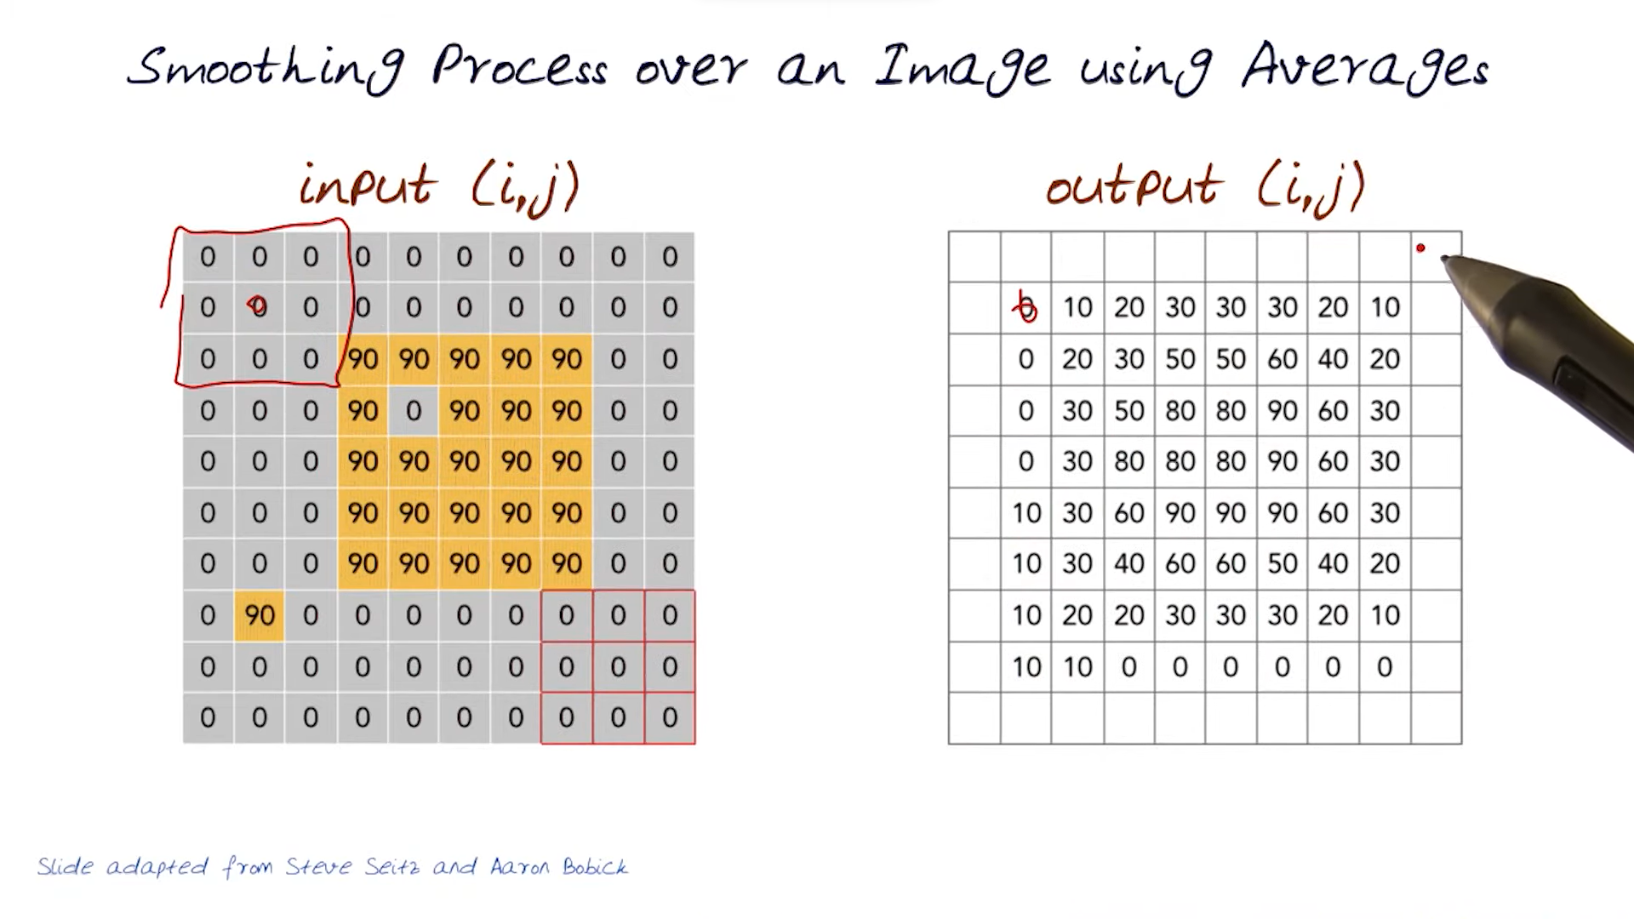

Note that when we take a 3x3 matrix and assign the average value to the centre of the matrix, the corner elements don’t get included. To solve this issue, we simply add another peripheral layer to the image that has the same values as the edge elements.

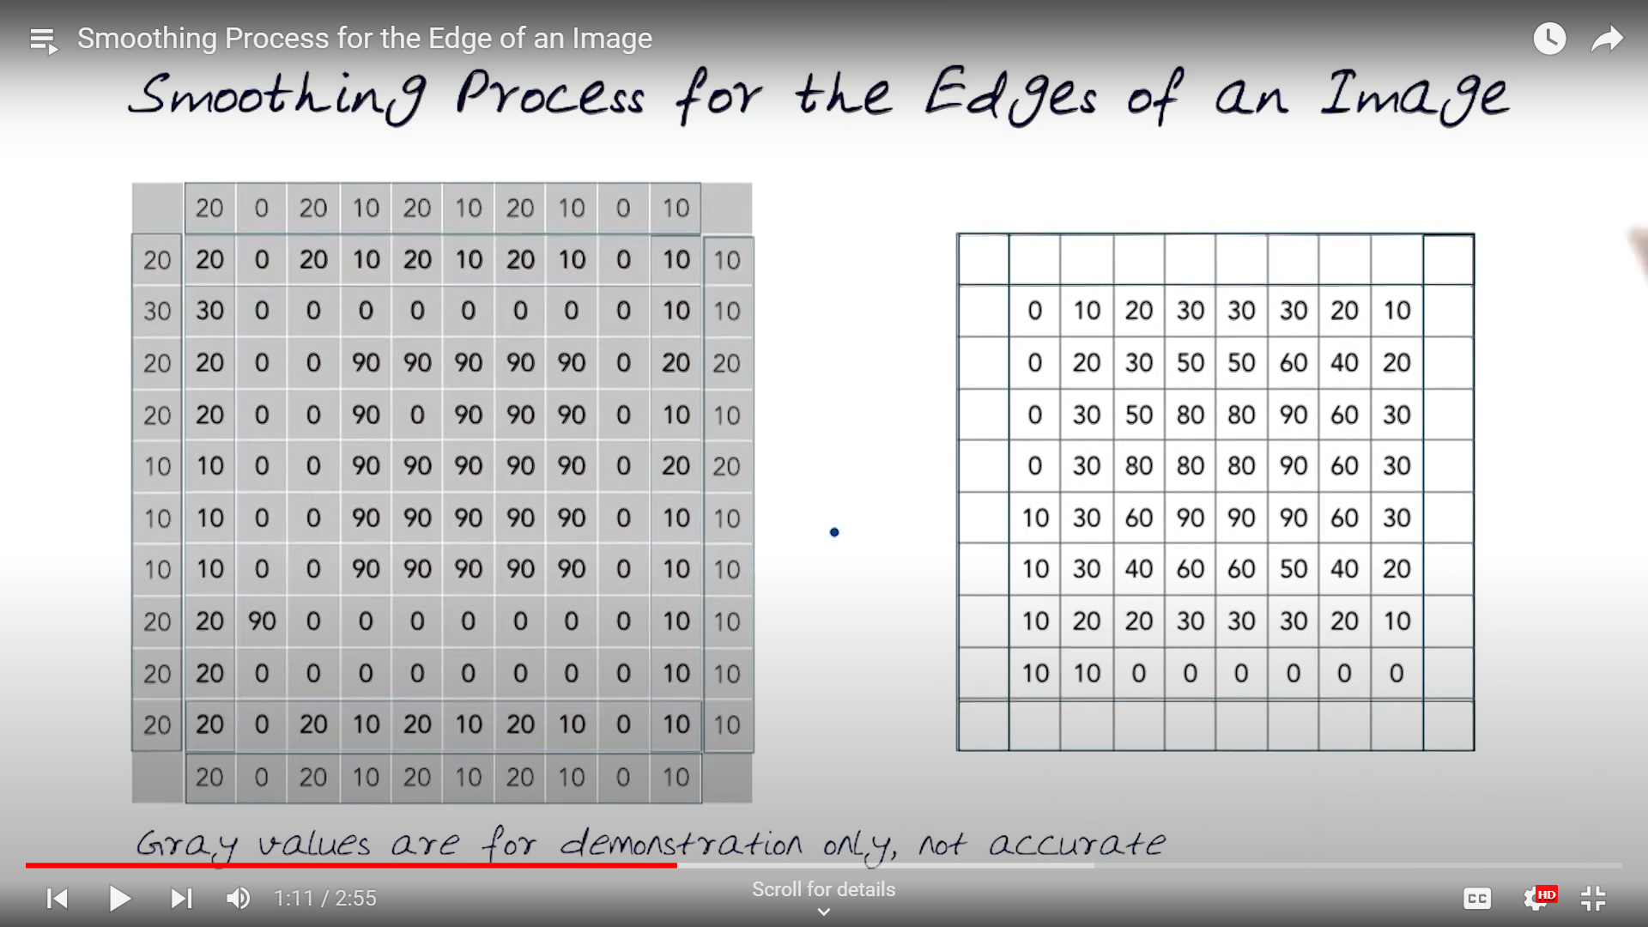

Other methods used for smoothening are taking median or applying gaussian filters. This process of iterating a matrix all over the image is called convolution and the iterating matrix is called kernel. Convolution is basically as follows:

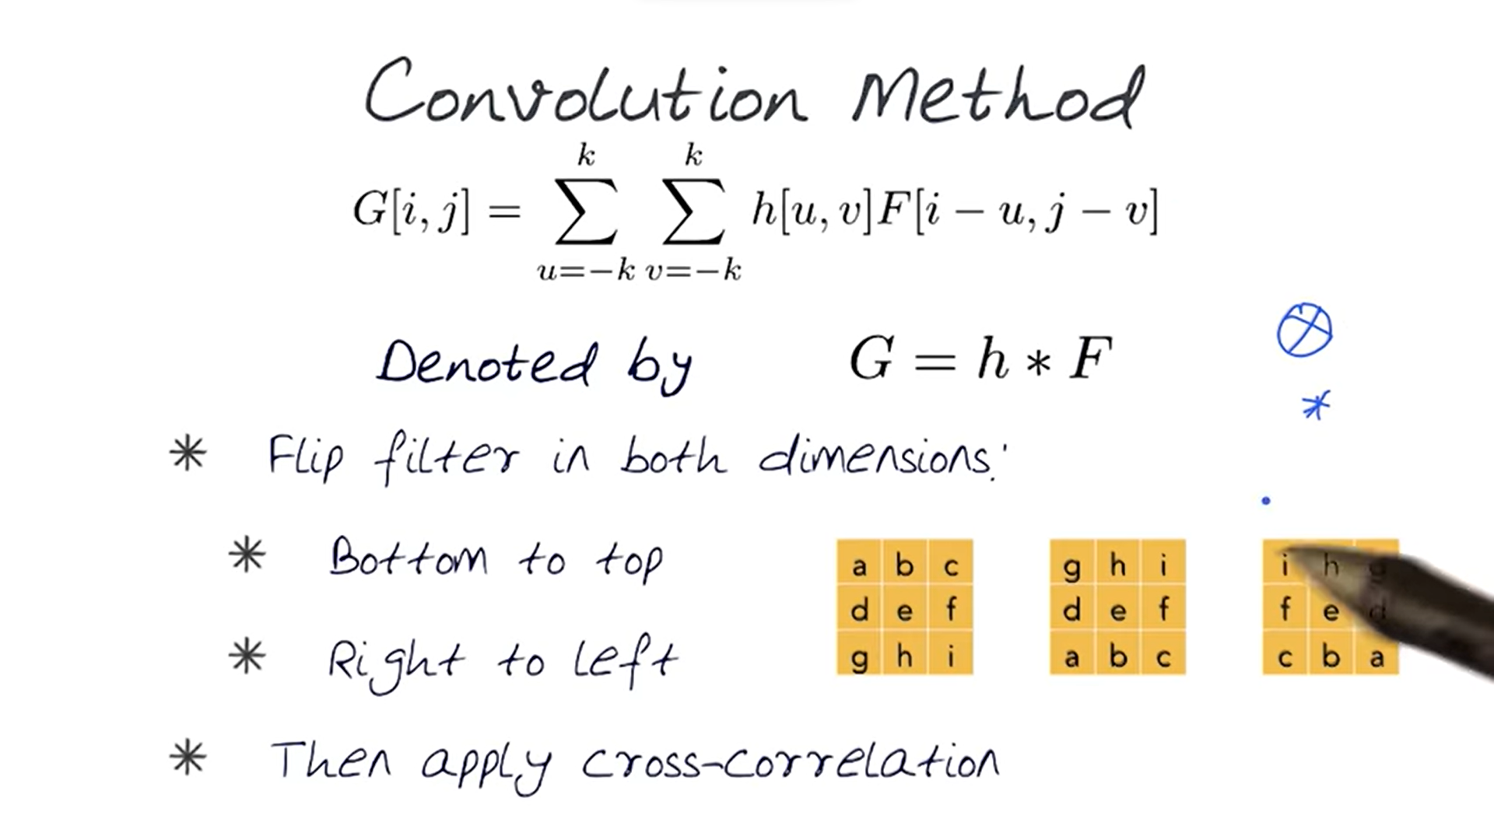

There are some interesting properties of convolution like associativity, commutativity and existence of identity matrix.

* After getting the smoothened image, we now proceed to the next step that is edge detection. The first thing is that we should understand what an edge is…

Edge is basically defined by rapid change in intensity within a small space. This happens because of various reasons, major being depth discontinuity. For detecting these edges, we can use different methods, eg. gradients and laplacian.

Gradient simply means first derivative. We find the “first derivative” of the image and wherever we get the most rapid change i.e. the highest magnitude of gradient, we define that as an edge. Now, what does “derivative of an image” mean? Basically, in a particular direction, the change of pixel intensity per unit length is the partial derivative of the image in that direction. So while in a 2d matrix, the del(I)/del(x) term would be simply the average of differences of intensities along the x axis per unit pixel length. Similarly doing this in the y direction, we get two directional derivatives representing the direction of steepest gradient corresponding to that pixel. Now, since (again!) this is simply a function of neighbouring pixels, we can consider this as a matrix multiplication, where the matrix to be multiplied is called the operator. This can be applied as a convolution along the entire image, and wherever we get the highest gradient values, we know that an edge exists there.

The choice of operator depends on us, with many gradient operators available readily with varying sizes, like Roberts operator which is a 2x2 operator which essentially just takes the difference diagonally and Sobel operator which has been famous for quite a long time. As the size of the operator increases, the detection capabilities increases, however this leads to lesser localisation as increased sizes also account for increased dependencies on surrounding pixels.

The second method used for edge detection is laplacian operator. Laplacian basically means 2nd derivative. When we encounter an edge, the first derivative attains a local extrema, thus the second derivative for that edge would be 0.

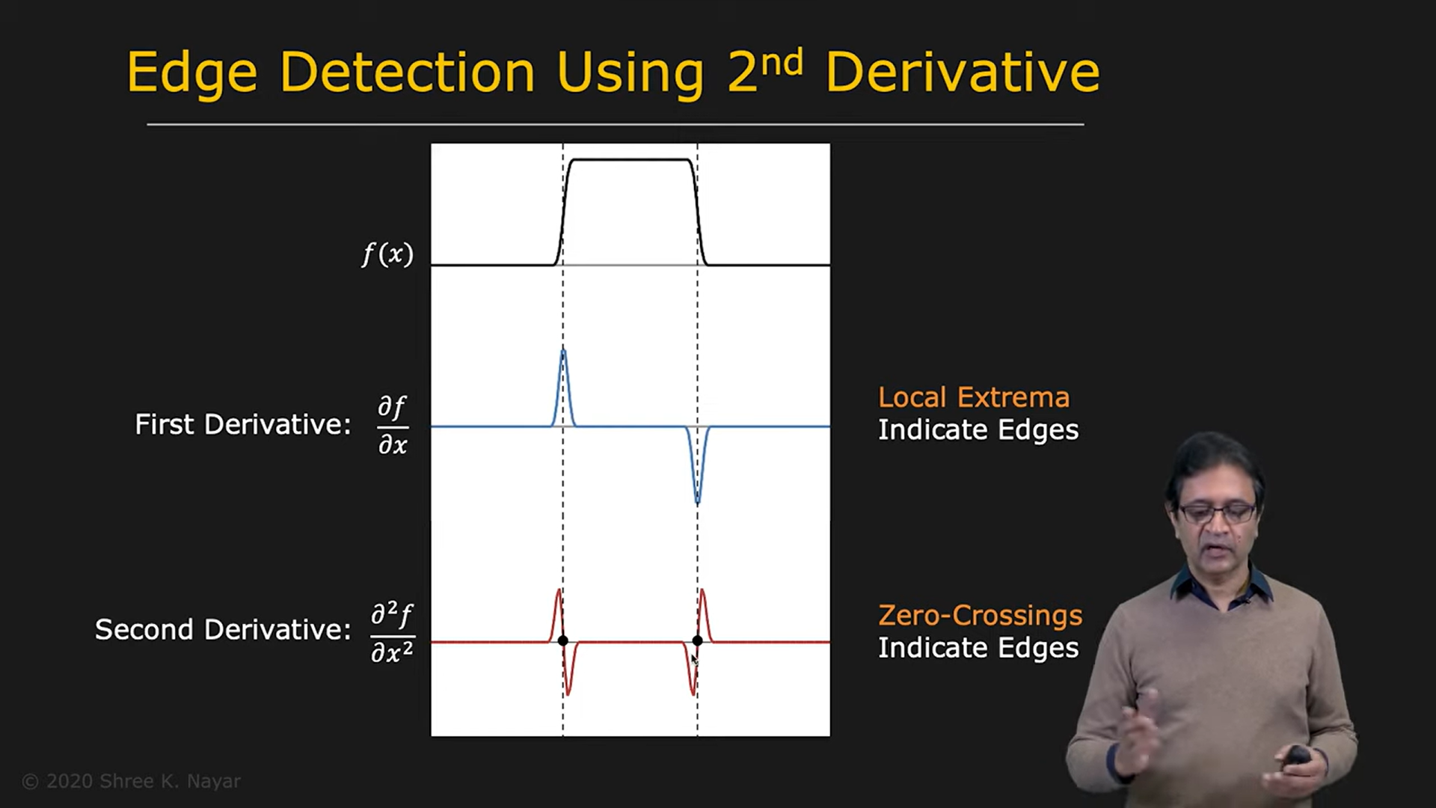

For finding the “second derivative of an image”, we simply take the derivative of the derivative. Thus, the laplace operator finds the change of the derivative of the image per pixel length. This, in fact, is the difference of the difference of adjacent pixel intensities per unit pixel length. Sometimes, for greater accuracy, we even consider the difference corresponding to diagonal elements for greater accuracy.

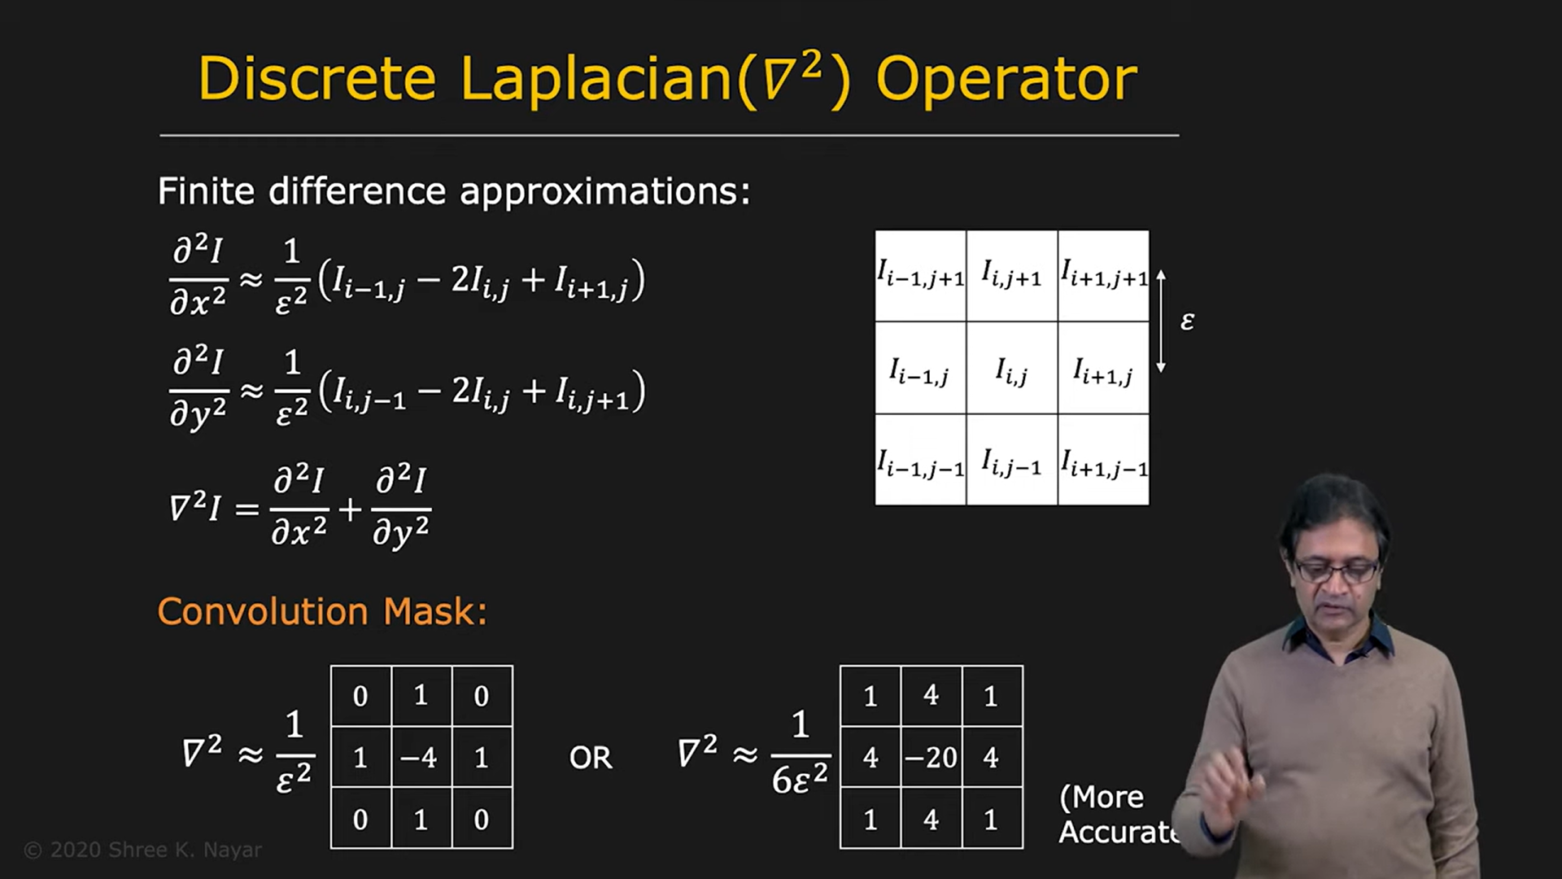

As seen in the above image, the 1st operator just takes into consideration the horizontal and vertical differences, but the second one, which is more accurate, also considers the effect of diagonal pixels. Note, when we consider diagonal elements, the epsilon in the denominator becomes epsilon*sqrt2, because the unit pixel length along that direction is actually sqrt2 times the original length.

While doing this, we need to also take into account the noises in the image which may make the detection process difficult. Thus, when we get an image, we first apply the gaussian filter and then use the laplacian operator.

Laplacian and gradient operators both have their advantages and disadvantages. So, we can apply the best features of both the operators to get an even better result. This is what the Canny edge detector does. First, we apply the Gaussian filter to smoothen the image, then apply gradient operator to find the direction of the derivative. Note, when we apply the gradient operator, it returns us two values: the partial derivatives of the image in the X and the Y direction. Thus, we can get the direction of the gradient at that particular point. Then, instead of using the usual laplacian operator, we use a 1D laplacian operator along that direction. This ensures that the pixels which are perpendicular(and also at somewhat higher angles to the gradient direction) don’t interfere in the derivative calculation. Thus, wherever we get a zero value for this derivative, we know that an edge exists there.

**Team Meet 1:**

Learned about the different pipelines(mono, stereo and lidar) and how all of these work together to achieve the aim of Perception: classify and find depth of the cones. Also wrote a code that drew rectangles around cones in a given image, given the coordinates of centre and other data(height, width of rectangle) from YOLO algorithm. Here’s the code I wrote:

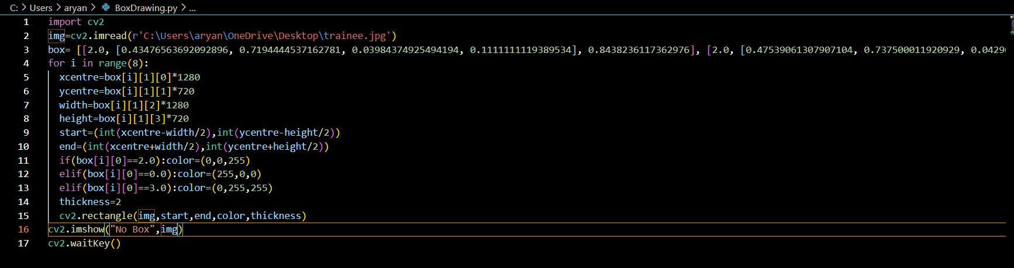

**Checkpoint 4:**

Learned the formal definitions of Machine Learning, Deep Learning, Supervised Learning, Unsupervised Learning, Artificial neural Network etc.

**Artificial Neural Network:**

These are layered computing systems inspired from the human brain’s structure. The layers in an ANN are input layer, output layer and hidden layer/s. Each layer consists of neurons, which have a particular activation typically between 0 and 1. Each neuron in a layer is connected to every neuron in the previous layer. The activation of a particular neuron is the weighted average of the activations of all the neurons in the previous layer. Thus the activation of each neuron is affected by the activations of all of its previous layers. These layers together constitute the network. The first layer in the network is the input layer, and the activations of the neurons in this layer are user defined. In the case of image processing, the input layer is the array having pixel intensities of the image. The network then takes the weighted average of these values and accordingly tha=e activations of the 1st hidden layer are assigned. Note that each of the neurons in the second layer can have different weights. These weights are initially set randomly, as the training of the network proceeds, these values are updated which i’ll come to later. Thus, we get the activations of the second layer which will serve as an input for the activations of the third layer, thus, we propagate forward in the network and finally get the activations in the last layer, which is the output layer. Now, based on the objective with which the network was built, the output layer differs. For example if we want a classification model that can recognise handwritten digits, the output layer will consist of 10 neurons, where the activation of each neuron will represent the probability that the model thinks that the given image corresponds to a particular digit. This process of updating the activation of neurons based on the weighted average of the activations of the neurons of the previous layer is called forward propagation.

Another concept that is used in finding the activation is the activation function. When we take the weighted average of the neurons, it might happen that the values are not normalised. So to avoid this, we use an activation function. An activation function is basically a nonlinear transformation which takes the input as the weighted average of the neurons of the previous layer and then produces an output which is assigned as the activations of the next layer. Some common examples of activation functions are Relu, Sigmoid function, tanh etc. For example, the sigmoid function takes in input as x and returns 1/(1+e^(-x)). Thus, all the values are squashed between 0 and 1 which make computations easier.

When we run our model for the first time, the weights between the layers are set to random numbers, because we don’t yet know what weights lead to optimal results. However, these values get updated in a process called training. In training, we provide the model with a training dataset. This dataset contains values imputed to the model and their corresponding expected outcomes. In very general terms, we give the model input and output, and the model finds out the relation between them. For this purpose, the model uses a concept called the loss function. The loss function basically gives an estimate of how wrong the model currently is! The aim of the model is to lower this loss function. The loss function basically finds the difference between the expected results and the model predicted results. These predictions are nothing but the activations of the last layer. Thus, the loss function is dependent on these activations and in turn can be written as a function of all the activations in the network and their corresponding weights. Now, for the model to predict accurately, we need to minimise this loss function. For this, we need to adjust the values of the weights to get higher accuracy. This is the exact aim of training.

The basic idea that is used for minimising the loss function is pretty simple: we compute the loss function in terms of the activations of the last layer, which in turn is a function of the activations of the second last layer and the weights between them. Thus, by changing the weights and activations, we can change the loss functions. Changing of weights is pretty straightforward, we can directly alter that. For changing activations, we can again take the activations as a function of activation of the previous layer and the weights in between them. Thus, we continue this process until we reach the first i.e. the input layer, whose activations we cannot change and thus we will have to only change the weights corresponding to the next layer. This process is intuitively exactly opposite to forward propagation, as in this we are moving backwards through the network, constantly updating the weights between all layers. This process is called back propagation and this lies in the heart of any training process. This process should be done as efficiently as possible, and thus the amount by which the weights get updated plays an important role here. For reaching the minimum quickest, we need to find the direction of steepest descent, that is the derivative of that function. Thus, in case of multiple parameters, we find the partial derivative of the function with respect to our concerning variable. In our case, the amount by which the weights between any two layers should be updated should be proportional to the partial derivative of the loss function with respect to that layer. This will ensure the fastest updation of weights which will result in the minimising the loss function. This idea of derivatives lies in the core of back propagation and thus is one of the most important concepts involved in training a model.

Some other concepts involved in Neural Network:

**One-Hot encoding:**  basically when we have more than one possible output i.e. more than one neuron in the last layer, the expected output is written in the form of a vector. This vector has dimension same as the last layer and all values except the value corresponding to the label equal to 0. Thus, the difference between this vector and the vector consisting of activations of the last layer is taken and the loss is calculated.

**Overfitting:** as the name suggests, when the model learns the data too well and also learns all the noises in the training data. The effect of this is that the model performs really well on the training data, whereas it fails when presented with unseen data. One of the possible solutions is to simplify the model, because the more complex the model is, the more likely it is to detect and learn random noises in the dataset.

**Underfitting:** sometimes the model is too simple and thus doesn’t learn from the dataset. As a result, the model performs poorly on the training dataset as well as test dataset. One of the reasons this might happen is that the derivatives come out as very low in number and thus, the changes in the weights is negligible. A possible solution of this problem is to make the model a bit more complex, thus increasing its learning capabilities.

**Learning Rate:** Learning rate is the proportionality constant I mentioned above, when the updation of weights is done, the amount by which the weights are changed is learning rate times the derivative. Thus we get:

W(new)=W(old)-(Learning Rate)*(Partial Derivative of loss wrt W)

**Zero Padding:** in CNNs, when the convoluted matrix is passed over the image, the dimensions of the image change. This happens, because when we take the dot product of two matrices, we assign its value to the centre pixel, thus causing a problem at the edge of the image. Suppose, we run a 3x3 convolution matrix over a nxn image, then the result that we will get would be a (n-1)x(n-1) matrix. Thus, to avoid this, zero padding is used, wherein the size of the initial image is increased by adding a layer of 0s all around

The image, thus turning it into a (n+1)x(n+1) matrix, which when convoluted will give a nxn matrix.

**Max Pooling:** Pooling is basically done to reduce the dimensions of an image. We convolate a matrix over the image by taking strides and taking the dot product of the matrices effectively reducing the dimensions of the image. Max pooling is a type of pooling that just takes the maximum value from a matrix. Thus the size of the image is reduced, but the dominant features remain pretty much the same.

**Regularisation:** regularisation is a technique to reduce overfitting in a model. Sometimes, some value of a weight or a bias becomes suddenly too large. Using regularisation, we can penalise the network for this by simply adding a term in the loss function of the form weight*constant. Thus, if a particular weight becomes too high, the model will try to reduce it.

**Checkpoint 5:**

Learned about the Stereo camera pipeline used in our car. Essentially, stereo cameras are a set of two cameras, which simultaneously take images and then based on these images, we use the disparity between two images to find the depth of any object. Firstly, we need to map an object in two images and then find out the distance between the same object in two images. This is the disparity of that object. Thus the depth of this object is given by:

depth=(focal length)*(baseline)/disparity

Here the baseline is the distance between the cameras.

Firstly, cones are detected in the left image by using YOLO software and then the keypoint in the image are recognised by using RektNet. These keypoints are then propagated to the right image by some method mentioned later in checkpoint 6. Then mapping between these keypoints is done using SIFT and thus, we find disparity.

**Checkpoint 6:**

**Patch Regression:** patch regression is basically a method in which an image is divided into small patches, which are essentially small square regions of pixels and then these patches are treated as individual data points. Then we aim to predict the value of each patch based on the values of the neighbouring patches. In the case of stereo cameras, we have one keypoint. We extract a small patch around that keypoint. Now, we compare this patch to patches in the right image, and wherever we find the most matching patch, we can safely say that the centre of the patch is the corresponding key point. For finding the “most matching” patch, we iterate over the right image and find the difference between corresponding patches. Basically, we take individual pixel intensity differences and add their squares. The patch for which this difference is the lowest, is the propagated keypoint. Pseudocode:

(X0,Y0)=keypoint

left_patch=left_image[

X0-Patch_size/2:X0+Patch_size/2,Y0-Patch_size/2:Y0+Patch_size/2

]

Patch_size=#some number

min=sys.maxint

For x in range(0,x(right_image)-Patch_size):

For y in range(0,y(right_image)-Patch_size):

right_patch=right_image[

X-Patch_size/2:X+Patch_size/2,Y-Patch_size/2:Y+Patch_size/2

]

error=mse(right_patch-left_patch)

If error<min:

min=error

prop=(x,y)

Return prop

**Using Epipolar Geometry:**

This is a method used for finding the correspondence between key points of two distinct images. Fundamentally, each camera has some intrinsic properties like focal length, principle point and I assume that we know these things about our camera. The principle point is nothing but the point where the principal axis of the camera intersects the image plane. Once we know these parameters of a camera, we need to calibrate it. Calibration means finding the relation between the 3D world coordinates and the 2d pixel coordinates of a point in the image. Consider the following:

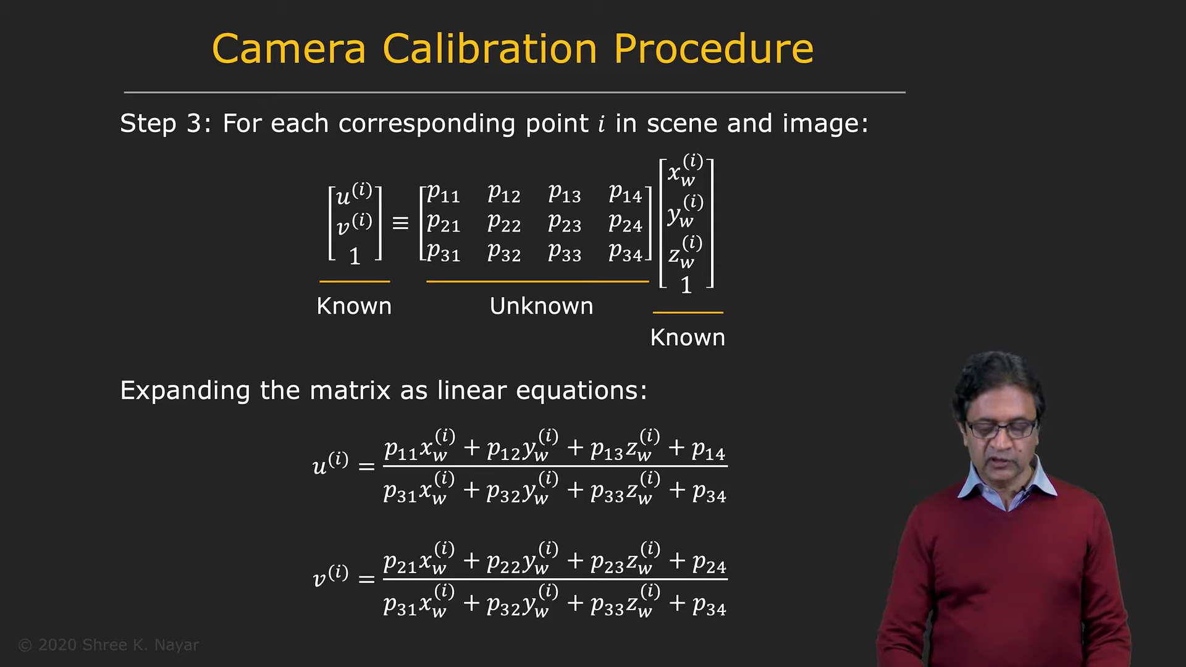

Here, u,v are the coordinates(pixel) of a point, in our case the keypoint, in the image and x,y,z are the coordinates of the same point in 3D space. So, essentially the problem reduces to finding the unknown matrix which is called the Projection matrix P. the thing to note about P is that it is defined only up to a scaling factor. In other words, scaling the elements of the projection matrix by a constant factor doesn’t change the projection it performs. This gives us the freedom of setting the scale of the projection matrix. One of most effective scales that is used is: ||P||^2=1.

Thus, the original problem reduces to finding P such that ||P||^=1 and Ap=0, where A is a known matrix. This reduces to finding minimum possible ||A*P||^2 such that ||P||^2=1. We define a loss function as to how close the ||A*P|| is to zero and the by differentiating it we get the following result:

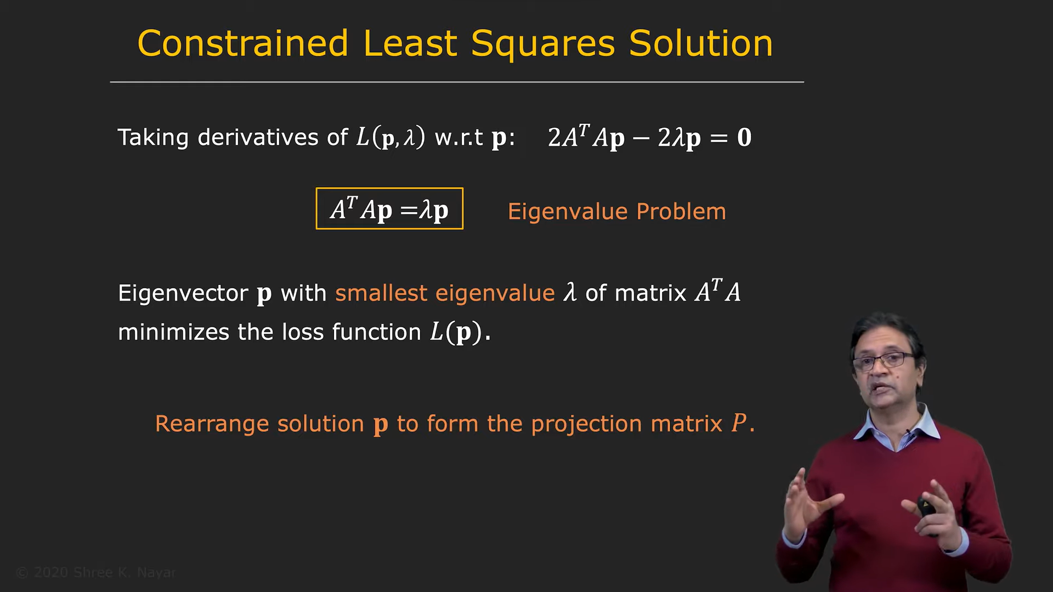

Now, what does this imply? Essentially, by finding P, we have obtained an equation of a line for a corresponding keypoint, such that the 3D point represented in the image must lie on that line. Thus, if we have this for both the cameras. If we knew the corresponding keypoint in the second image, we would do the same thing to that keypoint to obtain the line equation and then the intersection of those two lines would give the 3D point corresponding to the points. But, we don’t have the corresponding keypoint in the right image, and for finding those, we use epipolar geometry.

Consider the two cameras: we know their relative positioning with each other. We define the epipoles of the system as the projection of the camera onto the image of the other camera. We also define epipolar plane as the plane passing through both the cameras and the epipoles:

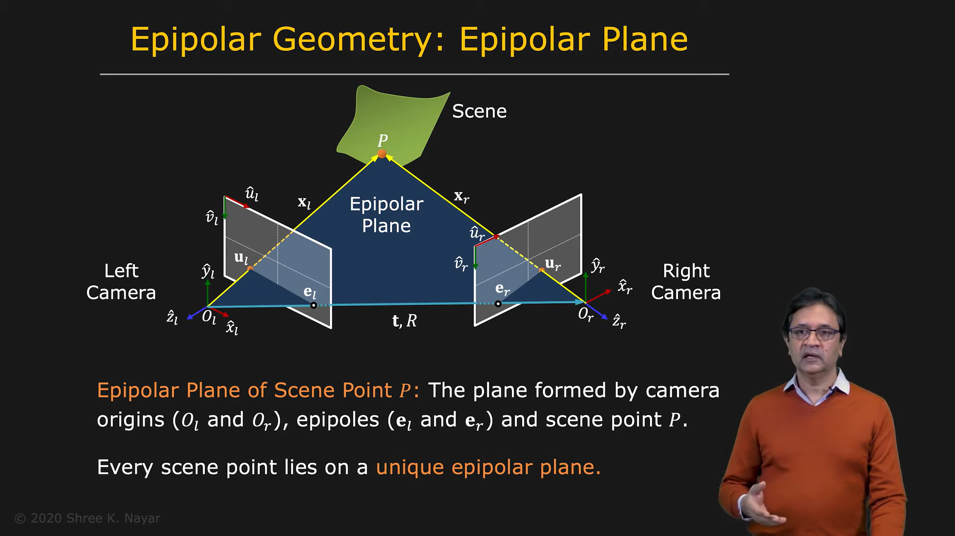

Note: in the above image, we have Ol,Or, el,er and ul, but not P(thus also xl and xr) and ur. We need to find ur.

Now, one of the interesting properties of this is called the epipolar constraint:

The vector perpendicular to the epipolar plane is t x xl  i.e. cross product of t and xl. But, since xl lies on the epipolar plane we get: xl.(t x xl)=0.

Writing this in matrix form gives us:

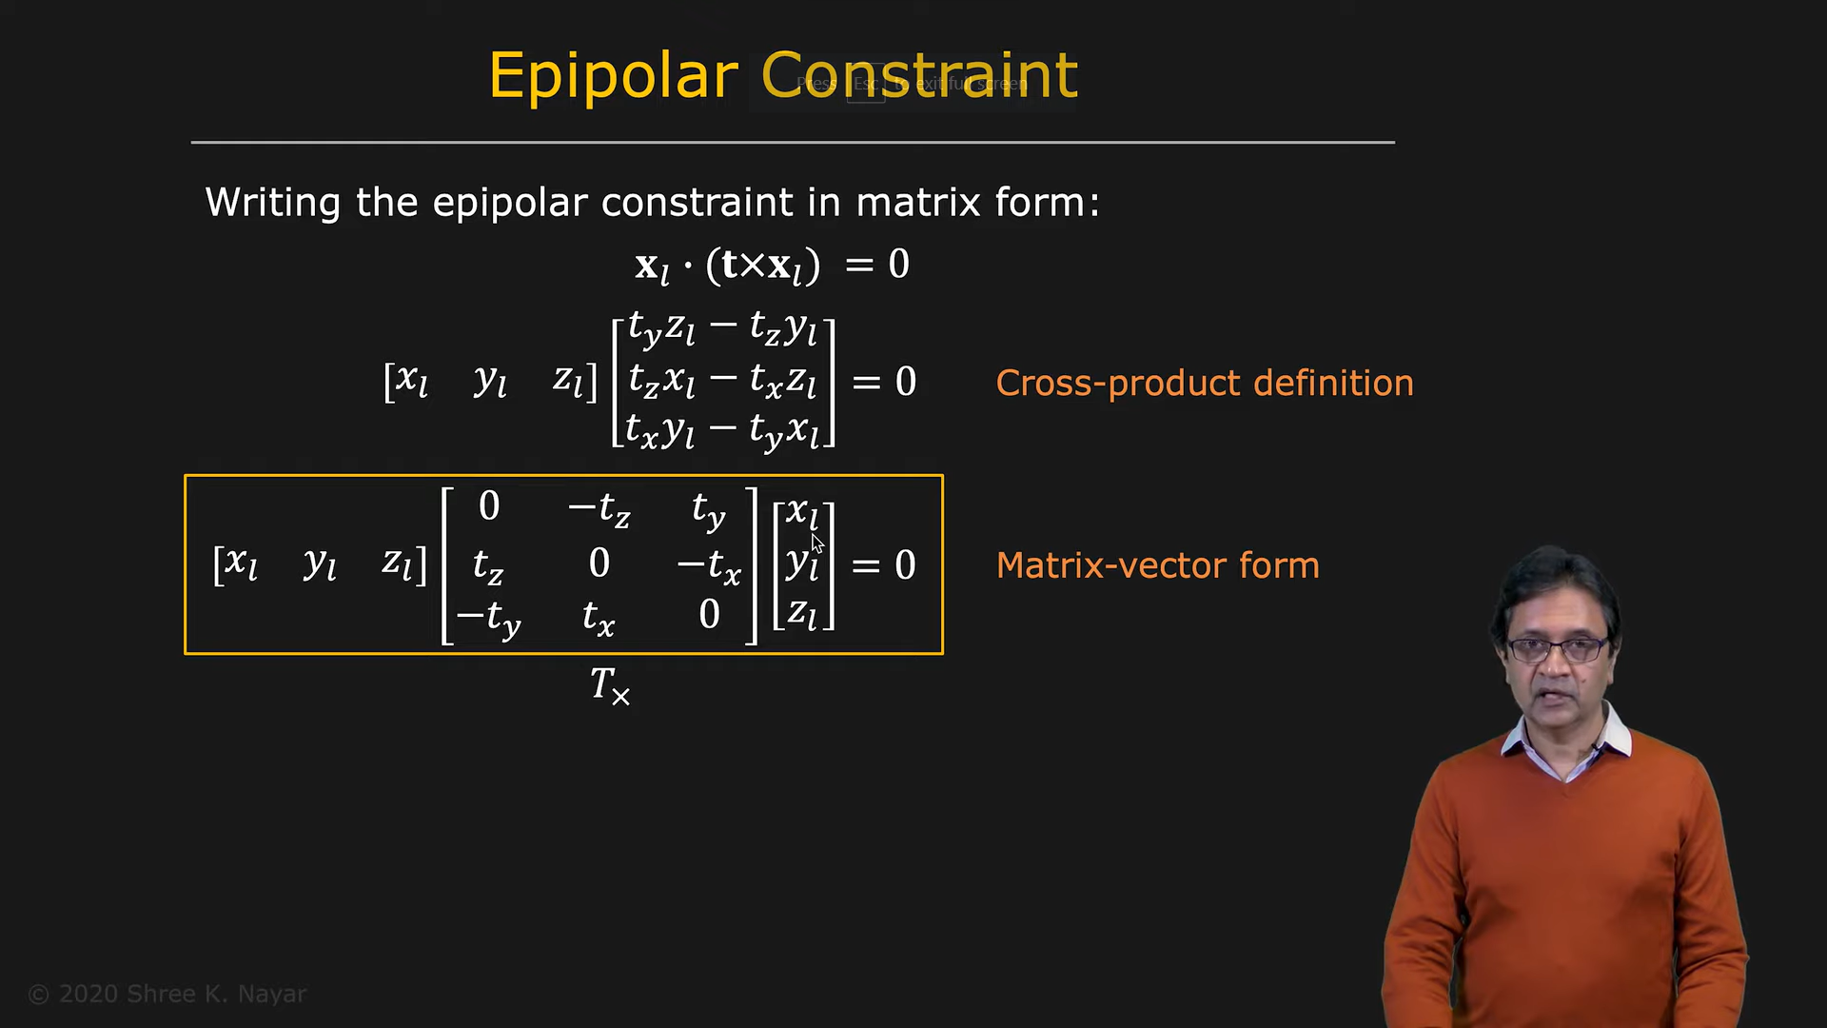

Here, xl, yl, zl are the 3D coordinates of the point in the left camera. Note: we don’t know them yet because we don’t know the depth of the object, but I’ll come to this later.

Now, since we know the relation between the orientations of the cameras, we know r and t and thus we also know xr, yr and zr.

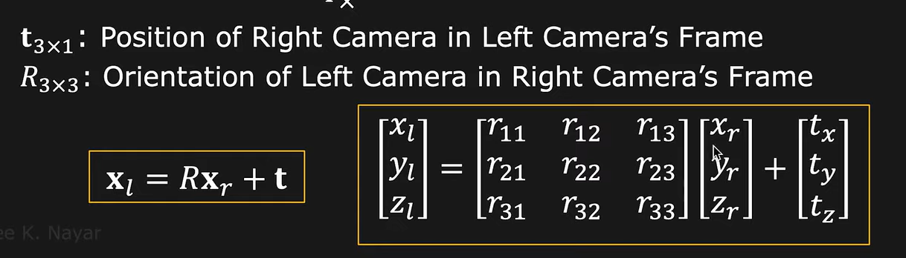

Thus, the xl(transpose) in the equation can be written in terms of xr, yr and zr and we get the following equation:

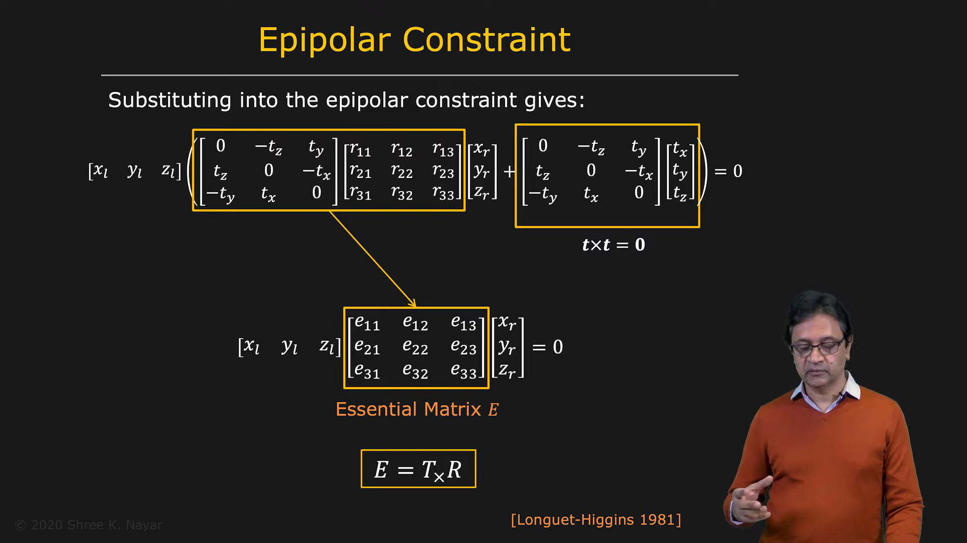

As seen above, we define an essential matrix, which is basically an intrinsic property of the stereo system. Note: as a side note, the matrix T is a skew symmetric and thus, even if we know E, we can use singular value decomposition to get R and T(not needed though!).

Now, we don’t know ul and ur. But what we know is the pixel coordinates of the key point in the left image and also the relation between those 2D coordinates and the 3D coordinates in space i.e. ul. We know this from calibration and thus, we can write ul in terms of the pixel coordinates, camera matrix(essentially the matrix obtained from calibration: consisting of focal lengths and the principal point) and the depth z as follows:

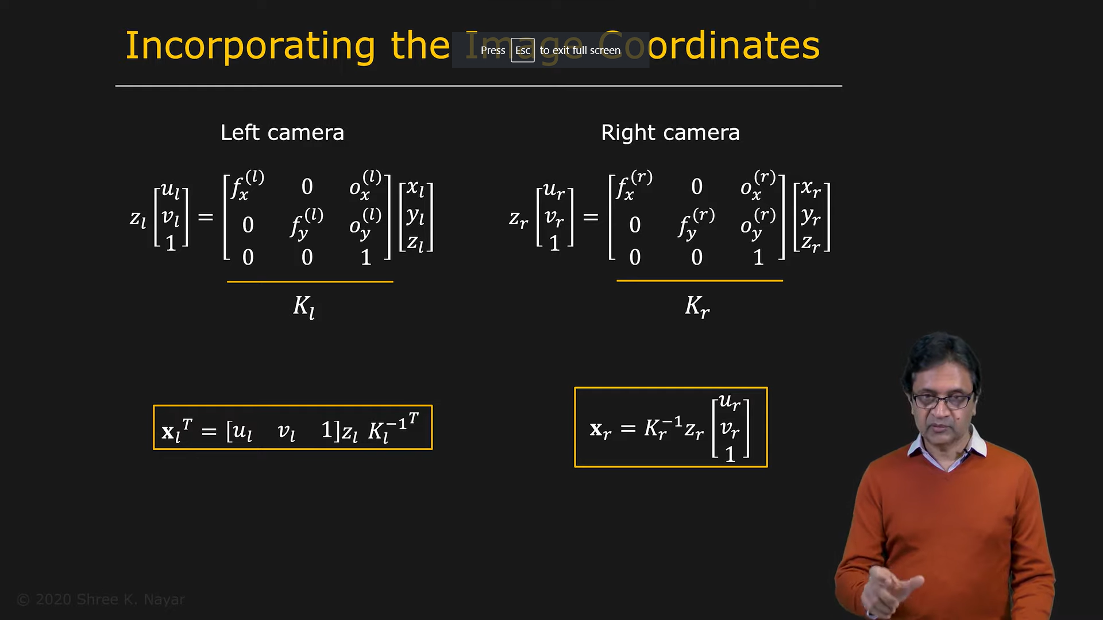

We substitute this into our original equation. Note, we don’t yet know z which is the depth of the object, if we would have known that we would have just gone over to SLAM! But here’s the interesting thing: z is the depth of the object and we know that that is not going to be zero, because zero depth essentially means that the object is on the camera itself. But, the RHS of the equation contains 0. So we just remove the terms zr and zl:

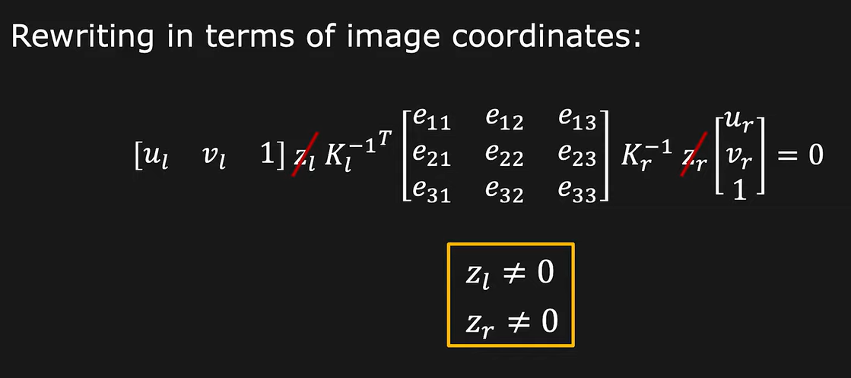

Thus, we get a new equation only in the terms of u,v of the left and right images which are the pixel coordinates of the object. We have ul and vl of the key point and thus we can find the **corresponding key point:** ur and vr by solving the matrix equation:

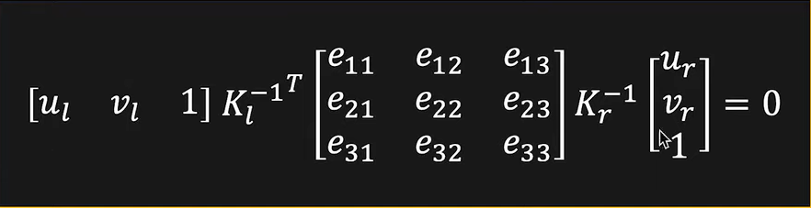

Here, Kl and Kr are the camera matrices of left and right cameras respectively. We define Fundamental matrix F as a product of K and E:

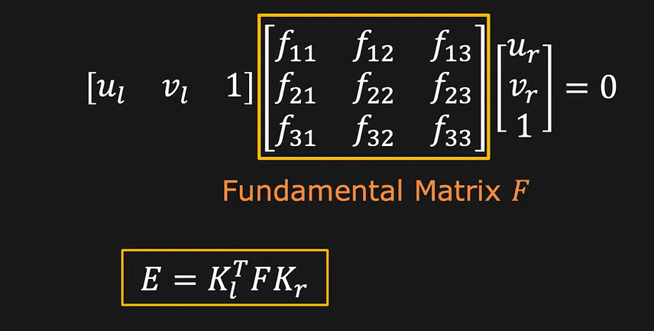

Thus, we have obtained a direct relation between the pixel coordinates of corresponding points in left and right images.

**Checkpoint 7:**

Essentially what I used in checkpoint 6! We need the relation between 2D pixel coordinates and 3D object coordinates. We need to find a pose matrix which, when multiplied by the 3D coordinates, will give us the 2d pixel coordinates of the object.

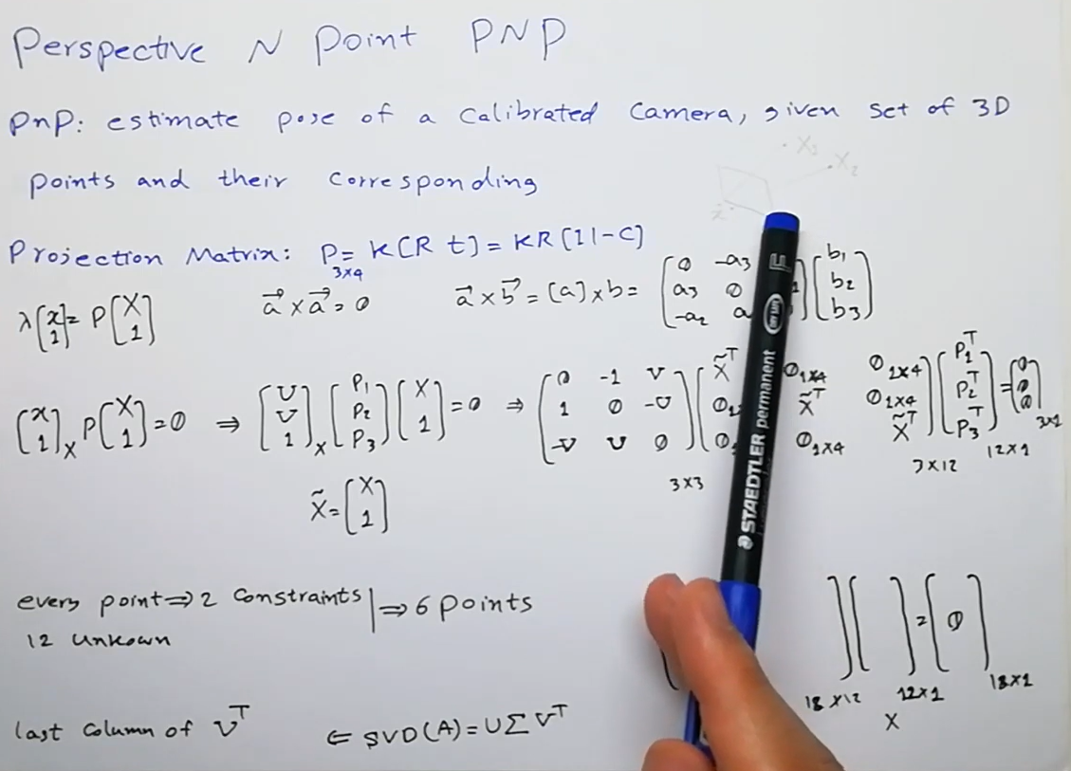

Thus for a 4x3 matrix, we have 12 unknowns and for each point we have 2 constraints, so we need mappings for 6 points to get the pose matrix.

**Assignment:**

Create number recognition model:

1. **Feed Forward using Keras/Tensorflow:**

[Feed Forward (Keras).ipynb](https://colab.research.google.com/drive/1U4_EEiospLrYPoq3Po5x5_t_1U16dSx7?usp=sharing)

Did the model using Tensorflow libraries, just used the built in functions. Tried out different learning rates, optimizers and activation functions. Finally got an accuracy of 98%+. Here’s one of the outputs I got:

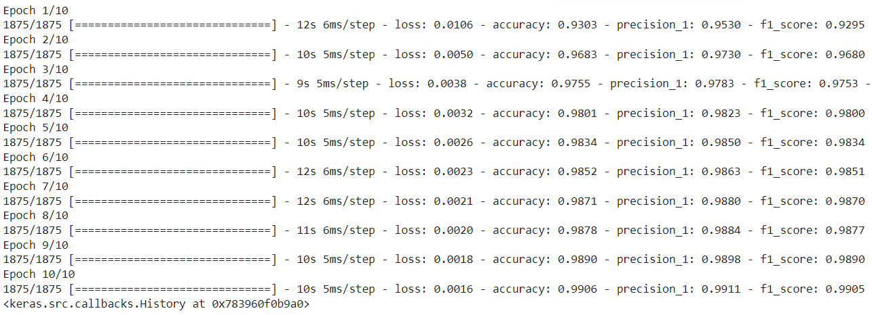

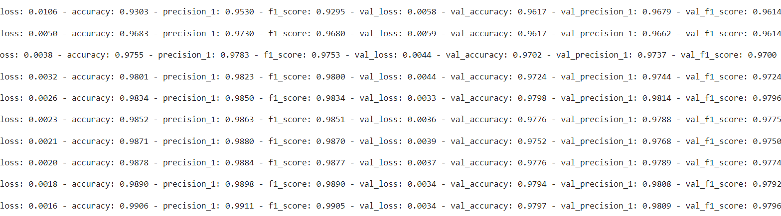

Problems faced: I tried SDG as optimizer first, but didn’t get too high accuracy. Then I shifted to Adam, but the learning rate required in Adam was too less. Took some time to figure out the optimal values of lr and optimizers.

1. **Feed Forward from Scratch:**

[Feed Forward (scratch).ipynb](https://colab.research.google.com/drive/1qL2nGGDKVBR0QxOIqe6W8W2NNo_s_3Ui?usp=sharing)

I had the same project in WIDS, so I had built a feed forward network from scratch. At that time the scope was very limited, so here, I added a lot of freedom in the model by allowing us to change the size of layers and so on. I even saved the weights and biases in my drive, so every time I didn’t need to start the training process all over again. Got accuracies of around 90%. But, when I had saved the weights and biases and then and epoched again and again, I had got to 96%+ from this model itself.

Problems: Well major problems in this included manipulation of the matrix sizes to fit with each other for dot products. Another problem which I faced was that accuracy didn’t improve at all in the beginning.A list of problems and how I solved it is given below in the project report:

[WiDS Project Report.pdf](https://drive.google.com/file/d/1Ppti90_CftUfM0qNv8sBgH3nSOBmL8_z/view?usp=sharing)

1. **CNN using Keras:**

[CNN (Keras).ipynb](https://colab.research.google.com/drive/1h6otMg_Utuazr0QVM7Fe8iQa_htsm7Mr?usp=sharing)

This was the first time I implemented CNNs. I used Tensorflow and the built in functions to make a network with 3 convolutional layers and 1 dense layer. Tried out many many different combinations, by changing kernel size, kernel number, number of layers, ordering of layers, size of dense layers, optimizers and also the order of the layers. Got really high accuracies with one even reaching 99.45%.

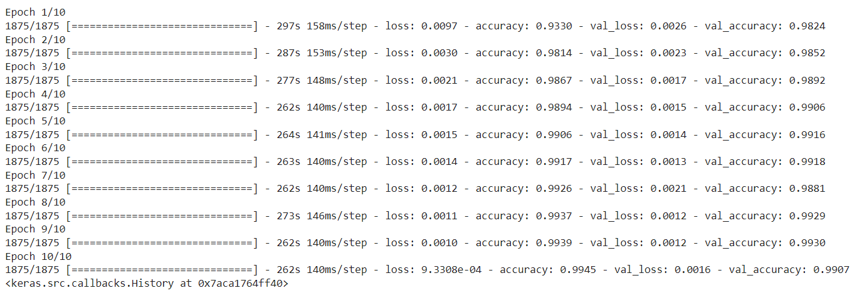

Problems: No real problems as such, the only place where time was spent was trying out different combinations.

1. **CNN from scratch:**

[CNN (Scratch).ipynb](https://colab.research.google.com/drive/1xVz1w6Bf2vfqV4k6ukrRsksvwotqaw-z?usp=sharing)

Not yet done completely. Took a loooot of time. Had to watch a couple of videos explaining back propagation in CNNs. Also had to constantly refer to github for references. Not yet tested on accuracy.